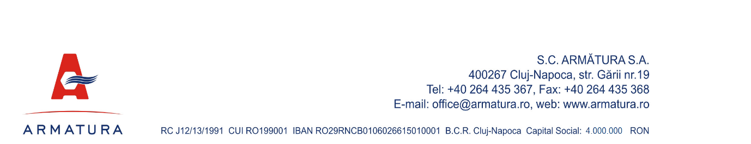

DECISION DRAFT NO. …../……………………….
of the Ordinary General Meeting of Shareholders of Company ARMĂTURA S.A.
issued on the basis of the Report no. .... / ......................

The Ordinary General Meeting of Shareholders of ARMĂTURA "SA Cluj-Napoca, gathered on ................................., at the .................. convening with a participation representing ................% of the subscribed and paid-up share capital thus decided on the issues included on the agenda of the Ordinary General Meeting of Shareholders.

1. Approves the management report on the Company’s annual financial statements drawn up for the financial year 2025 and the Board of Director’s report on the annual financial statements of the Company for the financial year 2025.
2. Approves the Company’s annual statutory financial statements, i.e. the balance sheet, the profit and loss account, the statement of changes in equity, the cash flow statement, the information data, the statement of non-current assets and the notes to the annual financial statements drawn up for the financial year 2025.
3. Approves the Company’s external financial audit report on the annual financial statements drawn up for the financial year 2025.
4. Approves the annual report drawn up in accordance with Article 63 of Law No 24/2017 on issuers of financial instruments and market operations and Article 126 and Annex 15 to Regulation No 5/2018 for the financial year ended 31 December 2025.
5. Approves the management discharge of the directors of the Company for the work carried out during the financial year 2025, on the basis of the reports submitted.
6. Approves the Directors remuneration report and the CEOs remuneration report afferent to the financial exercise of the year 2025.
7. Approves the Directors remuneration report and the CEOs remuneration report.
8. Chooses the Company ___________________ as an independent external financial auditor for a period of 1 year to audit the 2026 financial statements.
9. Approves the registration date for the application of the decision of the ordinary general meeting of shareholders as 28.06.2026, and ex-date 27.06.2026.
10. Approves the mandate of Mr PAUL DAN-VIOREL, member of the Board of Directors, to sign the decision of the general meeting and to mandate Ms Cristina Ghibaldan to carry out the formalities for its registration at the Trade Register Office of Cluj county.

By mandate granted by the general meeting signs:

PAUL DAN -VIOREL

